*About these instructions*

This document includes instructions on how to download the .pdf files:

1. Download PDF of Garment Patterns

2. Download PDF to Measure the Garment (this file is a photogrammetry image)

*1. Directions for Downloading and Plotting Pattern PDFs*

Before you attempt to recreate the clothing, you should have prior sewing experience as some of these garments are difficult to master. Some notches are included in the pattern. If you see a series of notches in a row, this will indicate where pleating is necessary. It’s highly suggested that you also print a picture of the garment so that you can recognize the details or peculiarities of the garment before you begin construction.

1. Download file. This might take a while depending on the speed of your computer and the plotter you are using.
2. You will need to print these patterns on a large format sized plotter. These patterns are full-size. If you don’t plot them on at least a 40” plotter, tiling may occur. In this case, you will need to tape together each pattern piece.
3. It is important that you use A0 sized paper when plotting the pattern pieces. The images will only plot to this size paper.
4. All patterns already include a 5/8” seam allowance and fold line marking. Please do not add additional seam allowances or the patterns will become too large in size. Pattern sizes vary from garment to garment.

*2. Instructions for Measuring Garment with Photogrammetry*

1. Copy and paste this web address into a browser: <https://apso.bsu.edu/2017/fashion_fusion/>
   1. Note: If you don’t copy and paste, you won’t have these instructions
2. Click on gallery in the top right once you’re on the home page
3. Click on garment: “Pink Day Dress.” This garment is on the first row, second from the left.
4. At the bottom of the page, there will be a “download pdf to measure garment.” Click the option and save the .pdf to your desktop.

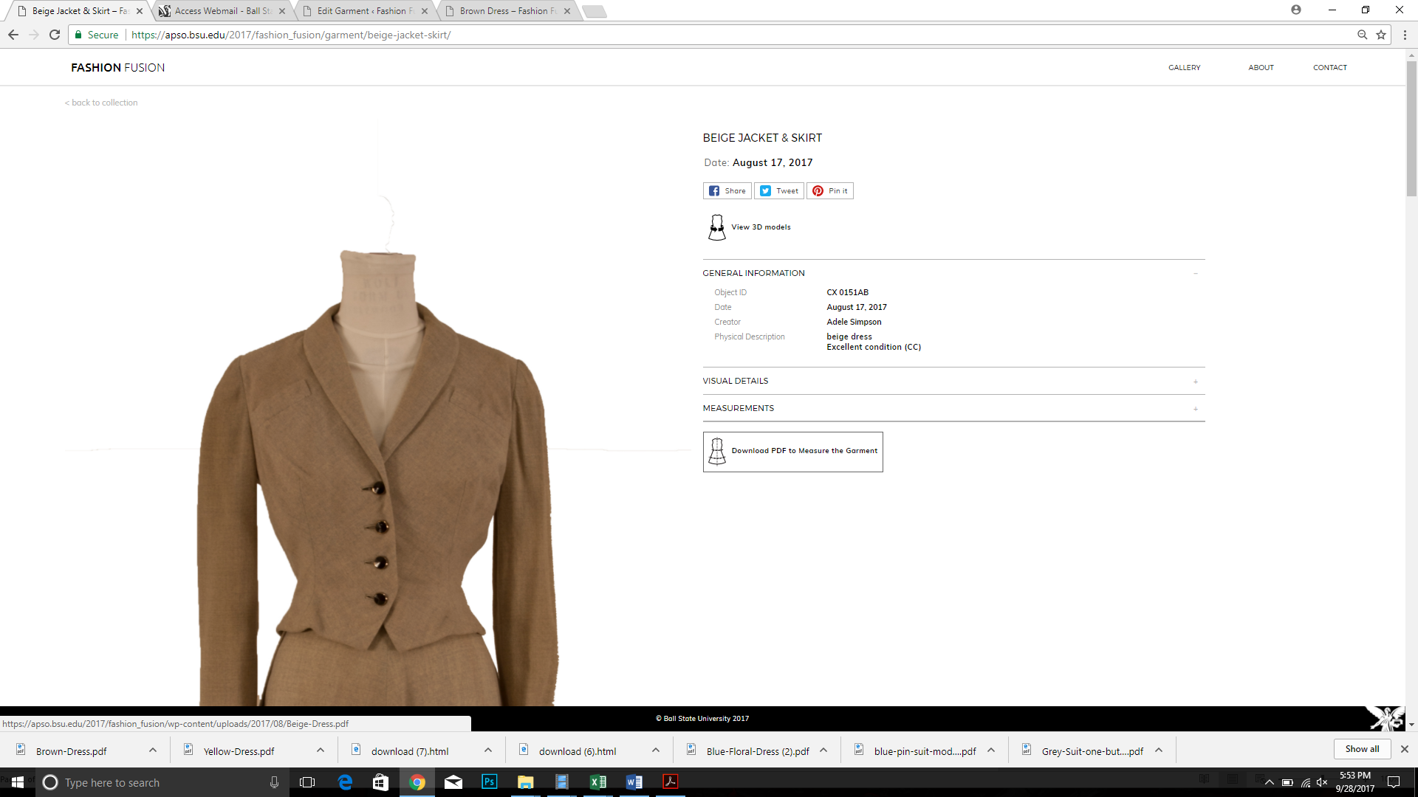

1. Drag and drop the .pdf file that you downloaded on your desktop into “Adobe Acrobat DC”

Note: Close out any dialog boxes that may pop-up when you first start Adobe Acrobat

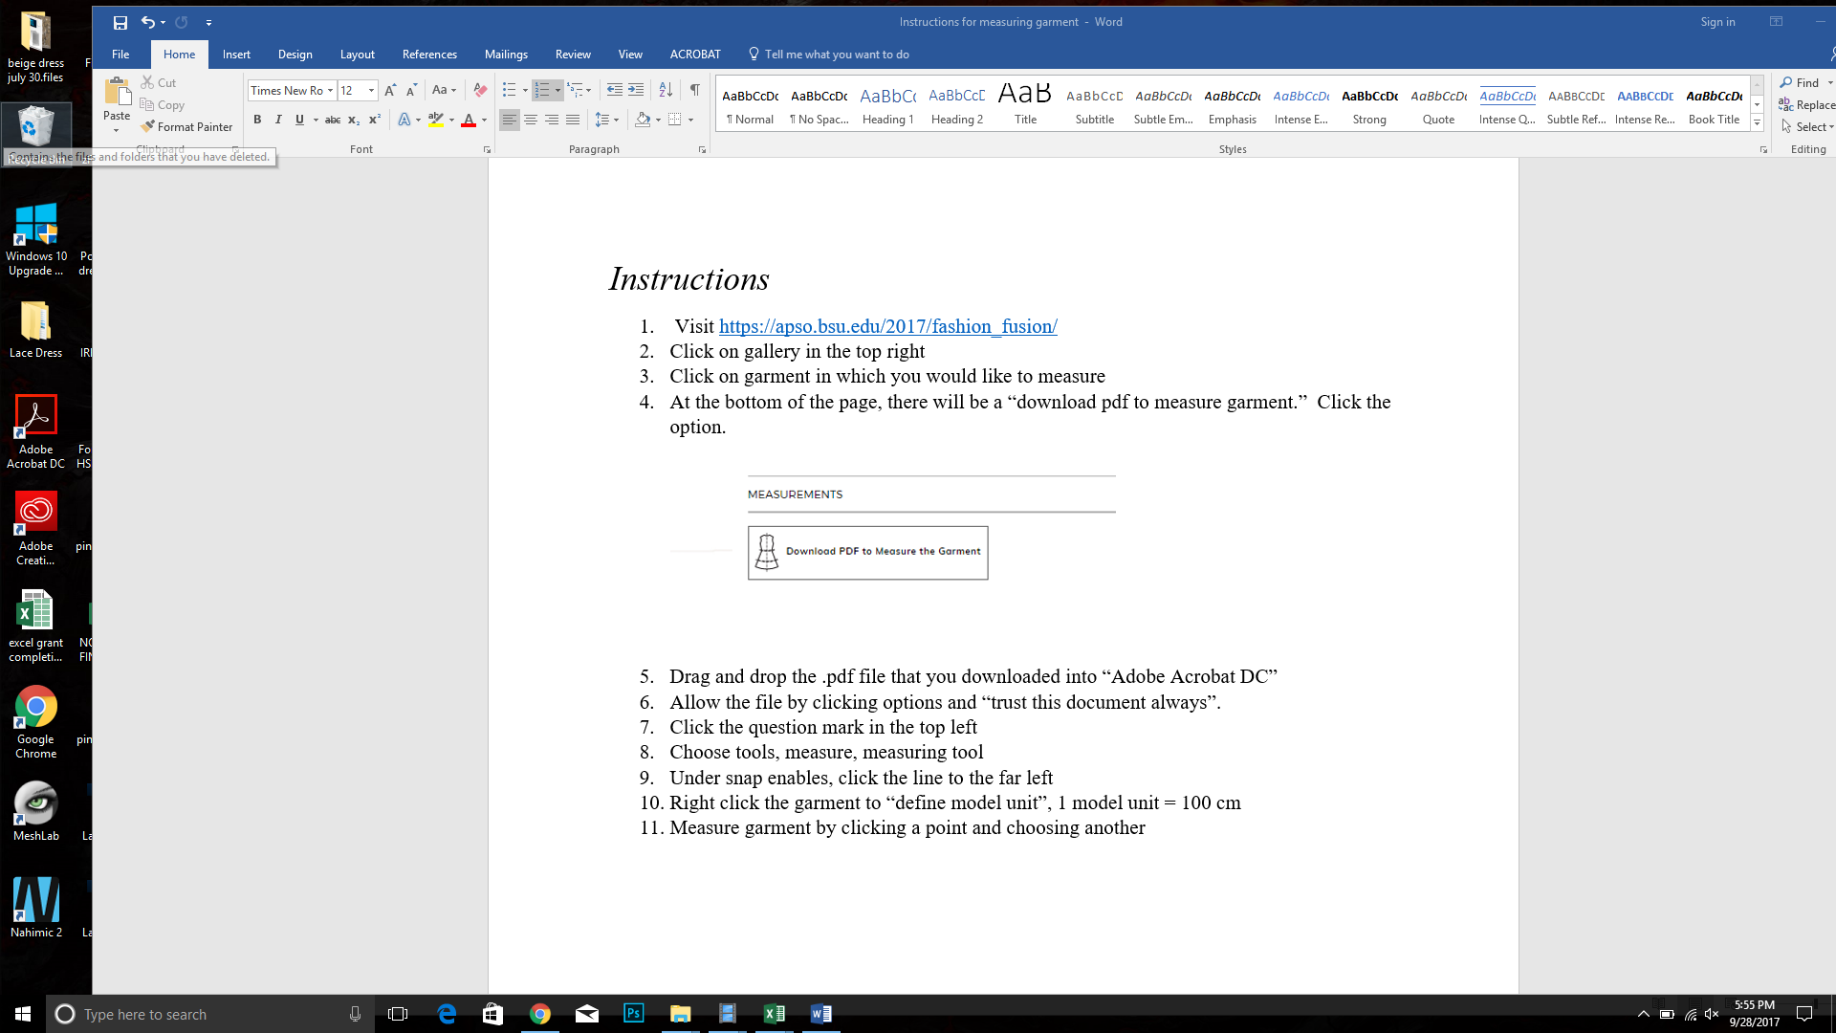

1. Allow the file by clicking options and “trust this document always”.

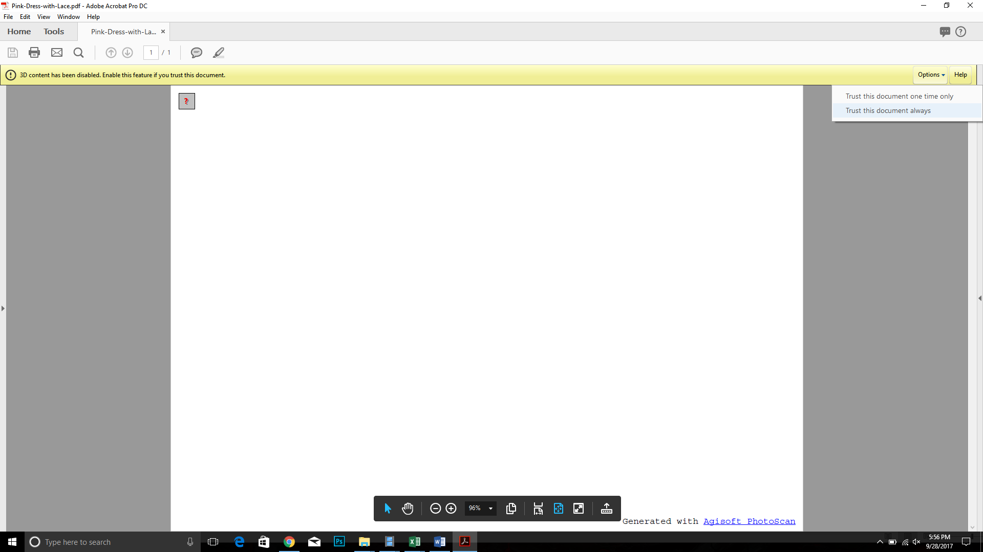

1. Click the question mark in the top left

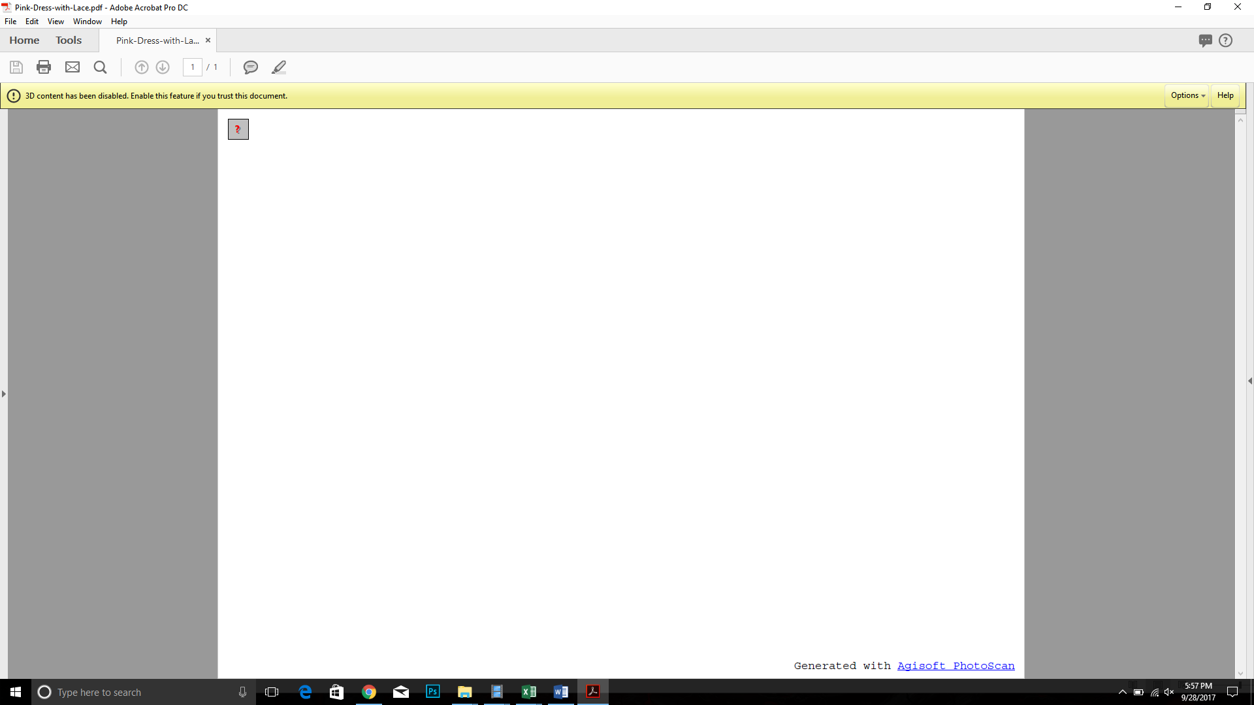

1. Choose tools, measure, measuring tool

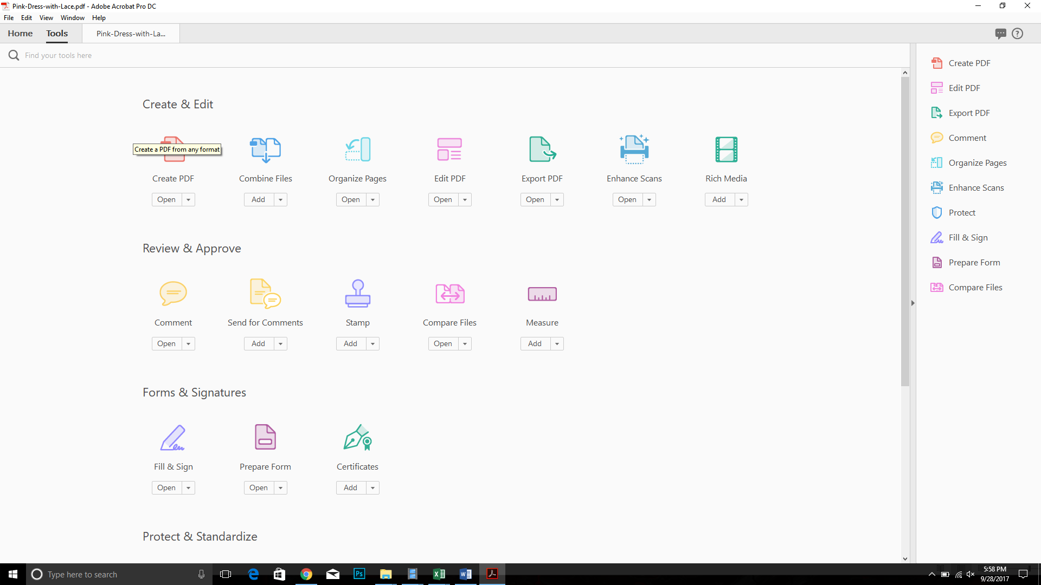

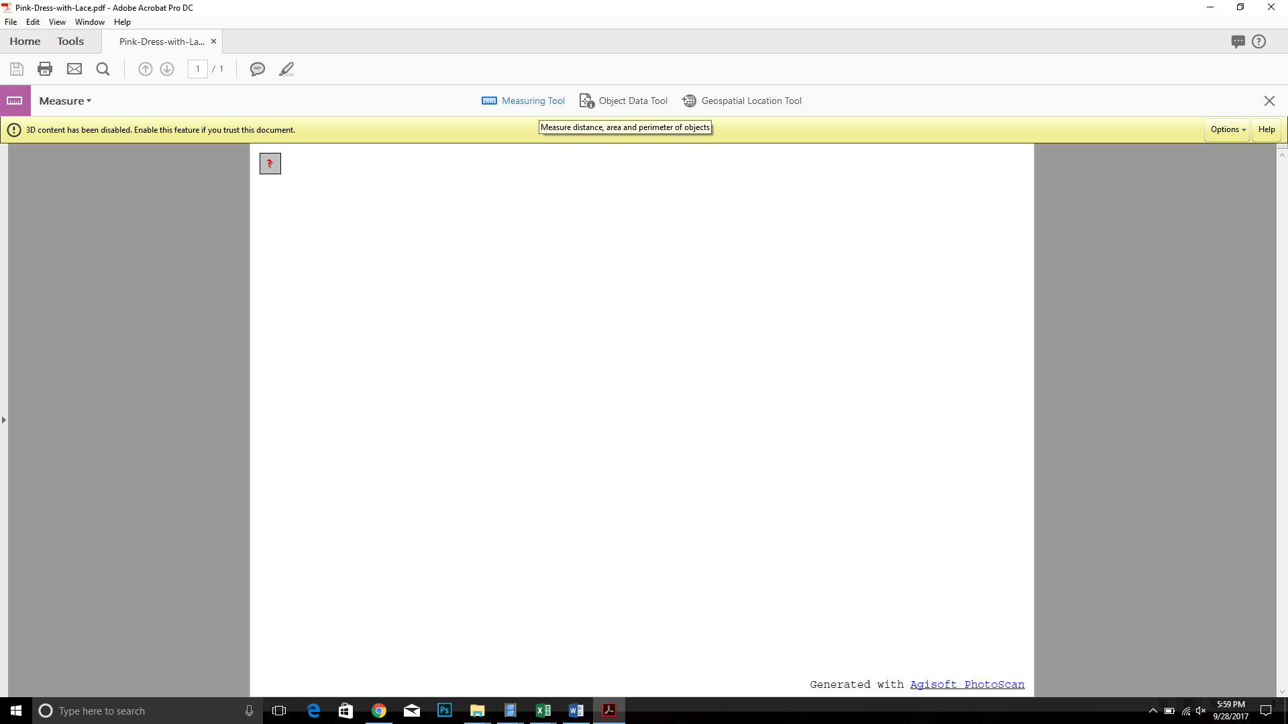

1. Right click the garment to “define model unit”, 1 model unit = 100 cm

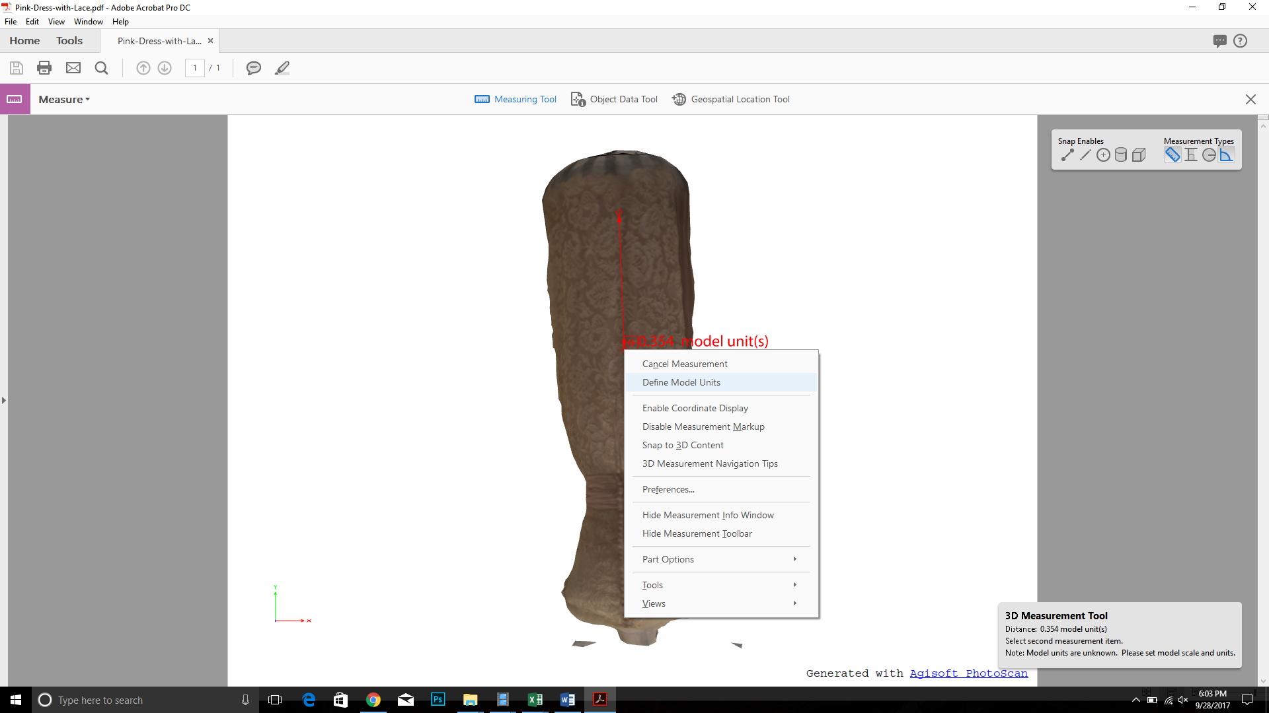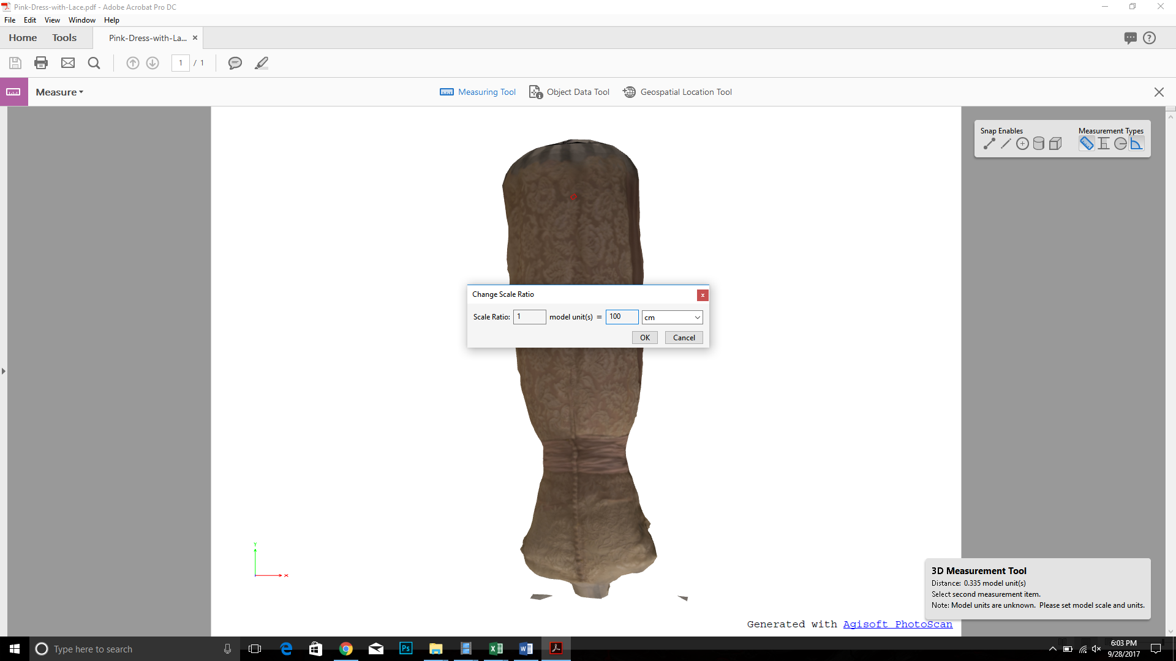

1. Measure garment by clicking a point and choosing another